

|  |
| --- |
| Task 2    **Integrate Grafana (3rd party monitoring tool) to Azure Virtual**  **Machine for Real Time**  **Monitoring** |

# introduction

**Grafana is an open-source platform that helps users analyze, monitor, and visualize data from multiple sources:**



## INSTALLATIon

* For installation on Windows, Mac, and other flavors of Linux, please refer the official documentation of Grafana:
* <https://grafana.com/docs/grafana/latest/installation/>
* STEPS:

1. sudo apt-get install -y apt-transport-https
2. sudo apt-get install -y software-properties-common wget
3. wget -q -O —<https://packages.grafana.com/gpg.key>| sudo apt-key add –
4. echo “deb <https://packages.grafana.com/enterprise/deb>stable main” | sudo tee

-a /etc/apt/sources.list.d/grafana.list

1. sudo apt-get update
2. sudo apt-get install grafana-enterprise
3. sudo service grafana-server start
4. sudo service grafana-server status
5. sudo update-rc.d grafana-server defaults

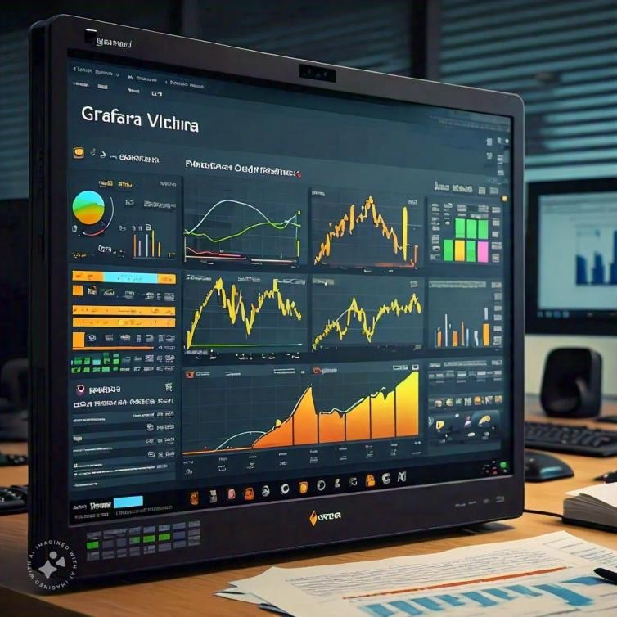

## Configuration

* Once the installation is complete open the Grafana tool on default port 3000
* http://YOUR-IP:3000
* Default username and password is admin which needs to be changed at first login.
* NOTE: Replace YOUR-IP with the public IP address of the VM where Grafana is installed



* Now we need to create a Service Principal and assign below permissions to the SPN:
  1. Reader permission at subscription level
  2. Log analytics Reader Permission for the subscription to read data from Azure log analytics.

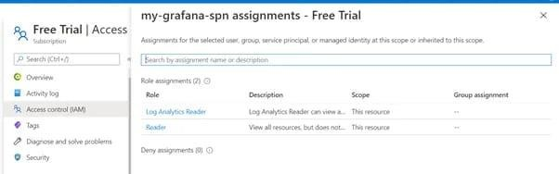

* 1. Log analytics API permission. (Active Directory -> API Permission -> Add a permission)

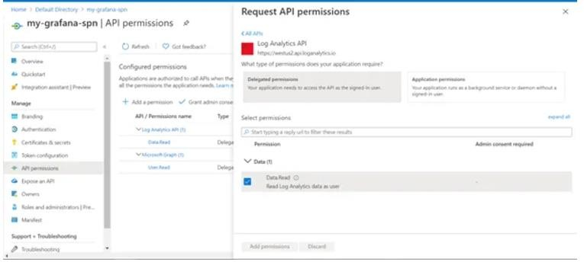

1.

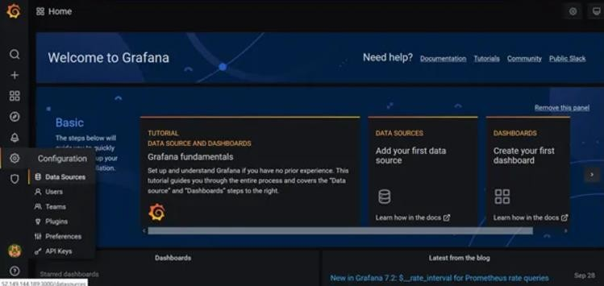

1. Click on Add data Source and search for Azure Monitor.

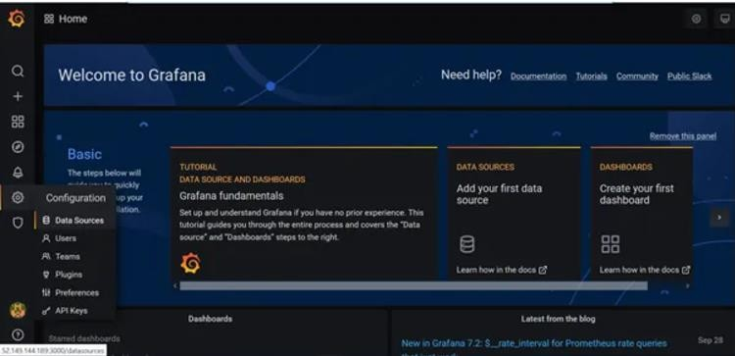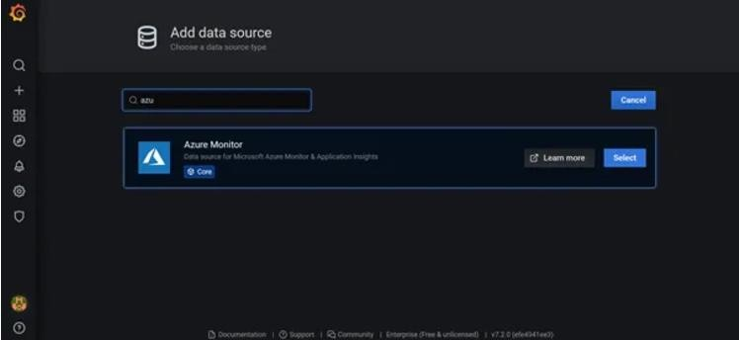

1. Fill the details of SPN in the Data Source.

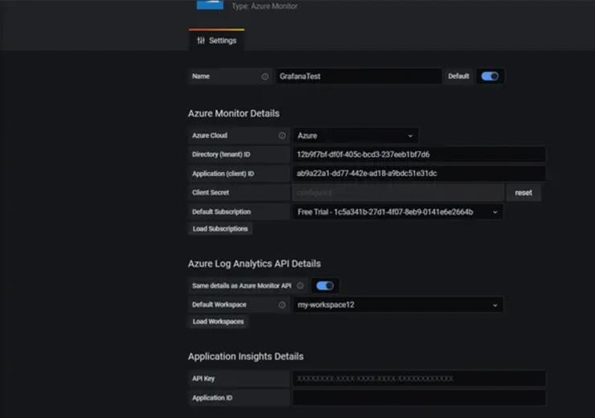

1. Now we have to create dashboard

### Dashboards

In this section I have created a dashboard using the data source configured in the previous section. It uses log analytics queries to fetch the data from perf table and display in Grafana. To list down the resource groups and VMs in those resource groups, we use a feature called as Variables which we can use in our log analytics queries.

***For creating variables please use below screenshots:***

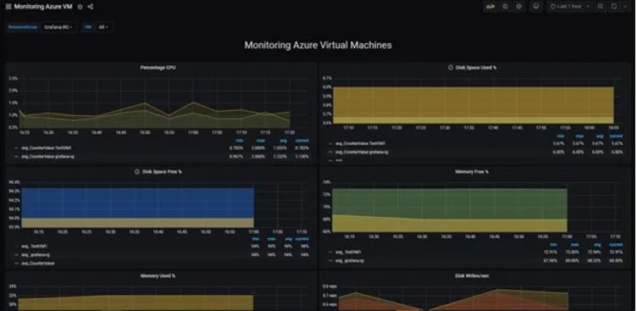

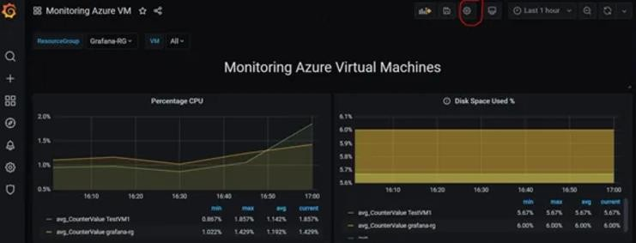

**1.Create a variable ResourceGroup to list down all the RGs in the subscription:**

**ResourceGroups()**

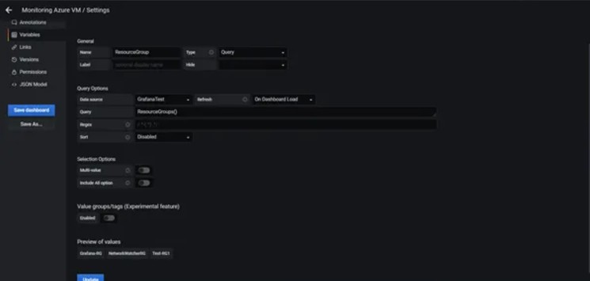

***2.Create variable VM to list down the VMs in RG:***

***ResourceNames($ResourceGroup,Microsoft.Compute/virtualMachines)***

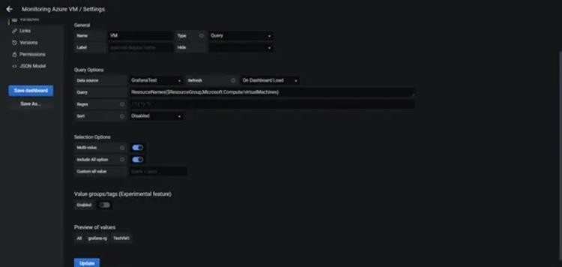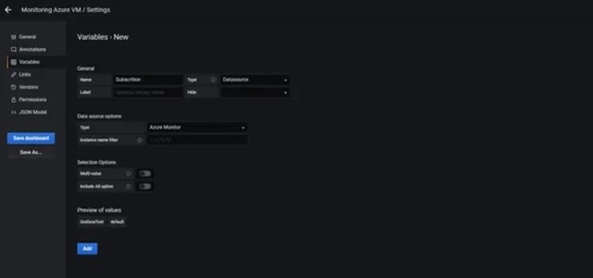

***Now once the variables are ready, we can use them in our log analytics queries for various metric monitoring.***

***Below are the few metrics which I used for monitoring Azure VMs:***

* **CPU Percentage(average): Displays the average CPU percentage for the last 5 mins**

Variable VM is used in the log analytics to display data for all the VMs in the selected RG.

Perf|where ObjectName ==”Processor” and CounterName ==”% Processor

Time”|extend vm=iif(Computer has “.”,substring(Computer,0,indexof(Computer,

‘.’)),Computer)|where (tolower(strcat(“””,$**VM**,”””)) has tolower(vm)) and

(Computer has vm)|where $__timeFilter(TimeGenerated)|summarize avg(CounterValue) by vm,bin(TimeGenerated,5m)| sort by vm asc , TimeGenerated asc| order by TimeGenerated asc

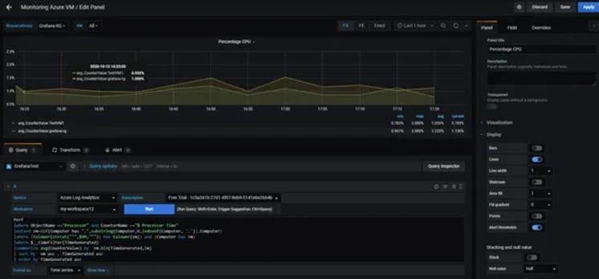

The scale of X & Y axis can be changed from Axes panel as shown in the below screenshot:

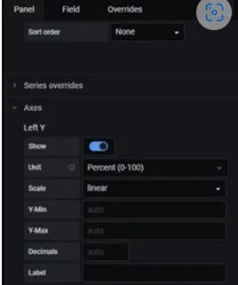

* **Disk Space Used (%): Displays the average disk space used in percentage on the VM for last 5 mins**

|  |  |
| --- | --- |
| • | Perf| where ObjectName == “LogicalDisk” or ObjectName == “Logical  Disk”| where CounterName == “% Used Space”|where InstanceName !=  “_Total”|extend vm=iif(Computer has  “.”,substring(Computer,0,indexof(Computer, ‘.’)),Computer)|where (tolower(strcat(“””,$VM,”””)) has tolower(vm)) and (Computer has vm)| where $__timeFilter(TimeGenerated)| summarize avg(CounterValue) by vm,bin(TimeGenerated,5m)| sort by vm asc,TimeGenerated asc| order by TimeGenerated asc |

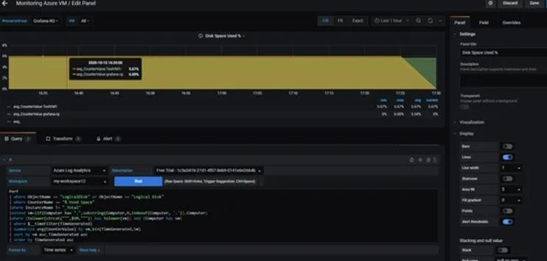

* **Memory Free (%): Displays the free memory (RAM) in percentage on the VM as an average of last 15 mins.**

|  |  |
| --- | --- |
| • | Perf|where ObjectName ==”Memory”|where CounterName ==”% Committed Bytes in Use” or CounterName == “% Used Memory”|extend vm=iif(Computer has “.”,substring(Computer,0,indexof(Computer, ‘.’)),Computer)|where (tolower(strcat(“””,$VM,”””)) has tolower(vm)) and (Computer has vm)| where $__timeFilter(TimeGenerated)|summarize avg(100-CounterValue) by vm,bin(TimeGenerated,15m)| sort by vm asc,TimeGenerated asc| order by TimeGenerated asc |
|  |  |

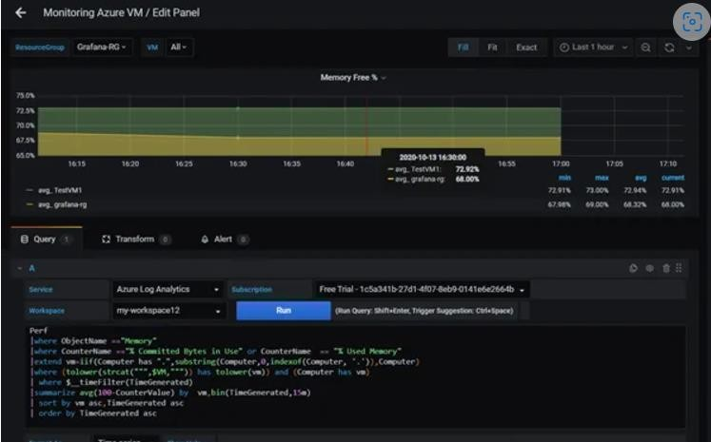

### CONCLUSION

**Grafana provides a big set of plugins for integration with multiple cloud providers and other tools like**

**Elasticsearch ,Graphite, Prometheus etc. Grafana also provides Reporting capabilities but it requires an Enterprise license. Grafana does not store any data which is a limitation but also good from a security point of view as it fetches real time data using REST API calls. So if you are looking for a centralized tool for monitoring of resources in multi-cloud environments or integration with other tools to improve visualization, Grafana is a good choice.**

***Thank You***